SAFETY AIDERS

PRESENTING

A REPORT

ON

TRAFFIC SAFETY

* Today “Road Safety” is one of the biggest public health issues throughout the country. Lakhs of lives are lost annually because of fatality due to road accidents, and the clock is ticking constantly. Road safety cannot be undermined if we want to achieve goals of sustainable development, prosperity and growth.
* Road Safety is imperative for a happy, healthy and prosperous life, of an individual as well as that of the nation. The issue concerns to all types of road users – pedestrians, motorcyclists, motorists etc., as well as unauthorized roadside vendors and other encroachers.
* With rising motorization and expanding road network, travel risks and traffic exposure grow at a much faster rate, as the growth of registered vehicles always outnumbers population growth and new roads constructed. Today road traffic injuries are one of the leading causes of deaths, disabilities and hospitalizations with severe socioeconomic costs across the world.
* As per the 'Road Accidents in India 2021', there were 4,12,432 unfortunate incidences of road accidents during 2021 which claimed 1,53,972 lives and caused injuries to 3,84,448 persons.
* As the road accidents are multi-causal which requires multi-pronged measures to mitigate the problems through concerted efforts of all agencies of both Central Government and State Governments.

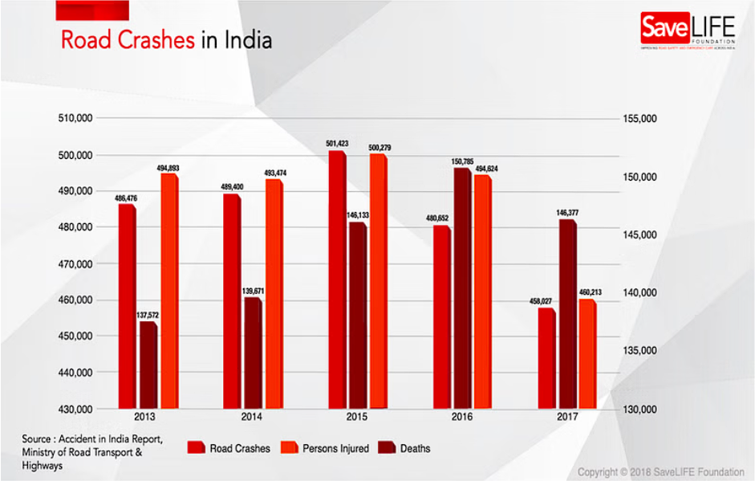

* **According to the**[**Transport Research Wing**](https://morth.nic.in/transport-research-wing)**, which came out with the Road Accident Report of 2019, road accidents can have multiple causes.**

**1. Over speeding**

The major cause of road accidents in these recent years is over speeding. It is also responsible for the greatest number of deaths and injuries in road accidents. Hence, drive within speed limits even when you are late.

**2. Driving without a Valid Licence**

Driving without a valid licence account for 9.9% of the total accidents. It may come as a surprise to readers to learn that drivers with valid licences accounted for a lion’s share of the total accidents! Meanwhile, driving with a learner’s licence accounted for[4.9% of the total accidents in 2019](https://morth.nic.in/road-accident-in-india).

**3. Driving in the Wrong Lane**

This traffic violation accounts for 5.4% of the total accidents in 2019, according to the [TRW’s report](https://morth.nic.in/sites/default/files/Road_Accidednt.pdf). As is noticed commonly, drivers do not keep to their lanes but cross lanes whenever they choose. This is very dangerous, and sudden swerving to the left or right can cause accidents.

**6. Jumping Red Lights**

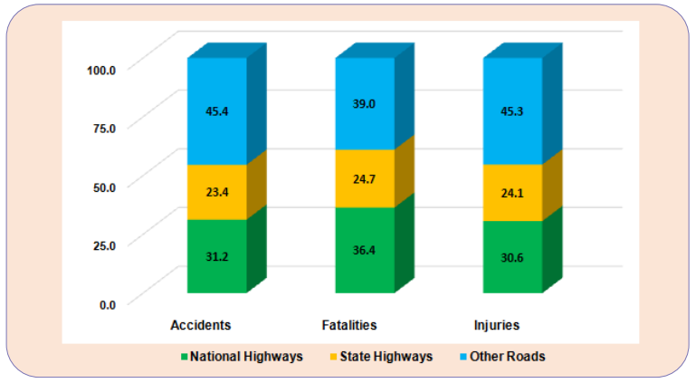This is the cause of 1.0% of road accidents in India. While this indicates vast compliance to the [traffic rules](https://www.godigit.com/traffic-rules/traffic-rules-every-motor-vehicle-drive-in-india-should-know), it is still a major cause of road accidents. Therefore, do not jump the signals as it may cause disasters.

Fig.: Categories of Roads Accidents, Fatalities and Injuries during 2021 (in percent)

**Revolutionizing Traffic Safety:** A Comprehensive Approach with Integrated Cameras and LCD Screens on Traffic Signals

**Abstract**

Traffic accidents pose a significant public health concern globally, with many attributed to driver inattention, negligence, and lack of awareness about traffic rules. Existing infrastructure often falls short in addressing these issues, leading to injuries, fatalities, and economic costs. This report presents a comprehensive solution aimed at enhancing traffic safety through the integration of cameras and LCD screens on traffic signals. This innovative approach focuses on creating public awareness, real-time violation detection, pedestrian safety measures, responsible data practices, legal compliance, and ongoing public engagement. By leveraging technology and proactive strategies, this project aims to revolutionize traffic safety and reduce accident rates.

**Introduction**

Traffic accidents continue to be a major concern worldwide, impacting public health, safety, and economic well-being. Despite advancements in road infrastructure and safety measures, accidents persist due to various factors such as human error, non-compliance with traffic rules, and inadequate awareness. In response to these challenges, this report proposes a comprehensive traffic safety project that integrates cameras and LCD screens on traffic signals. By combining technology with targeted awareness strategies, the project aims to minimize accidents and promote responsible driving behaviors.

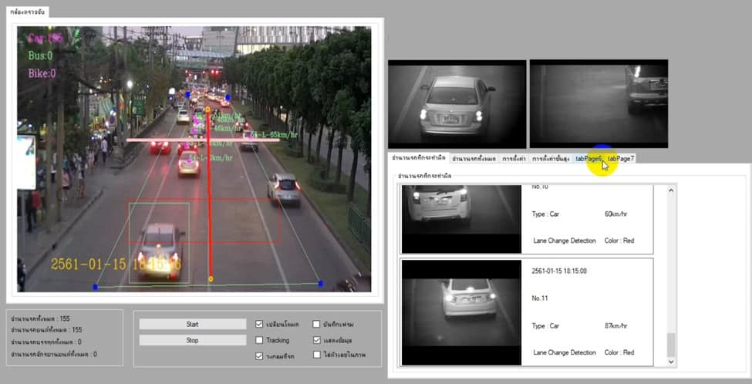

**Problem Description**

Traffic accidents result from a multitude of factors, including driver inattention, negligence, and disregard for traffic rules. Despite ongoing efforts to improve road safety, existing infrastructure may not effectively address these issues, leading to significant consequences such as injuries, fatalities, and economic costs. There is a need for innovative solutions that not only detect violations but also educate and raise awareness among the public to prevent accidents.

**Solution Overview**

The proposed solution involves the development and implementation of a comprehensive traffic safety project that integrates cameras and LCD screens on traffic signals. This project focuses on creating awareness among the public through dynamic messages or animated videos displayed on the LCD screens, covering topics such as recent traffic rule updates and safe driving practices. Additionally, the system captures and displays live violations through cameras installed at strategic locations, providing real-time deterrents to rule-breaking behaviors. Integrated sensors at zebra crossings detect pedestrian presence, activating alerts to both drivers and pedestrians when rules are violated. The refined system utilizes intelligent data processing, visual and audible warnings, and a strong emphasis on public engagement to revolutionize traffic safety.

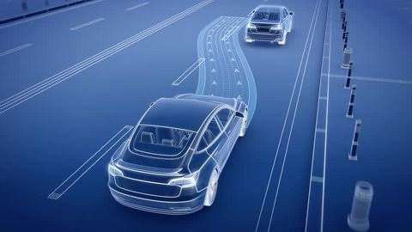

**Key Components of the Solution**

1. Traffic Safety Awareness Messages: Dynamic messages displayed on LCD screens cover various topics to educate and remind drivers about traffic rules and safe driving practices.

2. Real-time Violation Detection: Cameras integrated with microcontrollers capture live footage of traffic violations, with confirmed violations displayed on LCD screens along with specific rule infractions and potential fines.

3. Pedestrian Safety Measures: Integrated sensors at zebra crossings detect pedestrian presence and activate alerts when vehicles disobey crossing rules, promoting pedestrian safety.

4. Responsible Data Practices and Legal Compliance: Measures are implemented to ensure responsible data practices and compliance with legal regulations regarding surveillance footage and personal data.

5. Ongoing Public Engagement: Continuous public engagement through awareness campaigns, community involvement, and feedback mechanisms is essential for project success.

**Implementation Strategy**

The implementation of this comprehensive traffic safety project requires collaboration with stakeholders such as law enforcement agencies, local government authorities, traffic management departments, and community organizations. Key steps include:

- Conducting a feasibility study to assess infrastructure requirements and potential locations for camera and sensor installations.

- Developing and testing the integrated system in controlled environments before deployment.

- Implementing data privacy measures and legal compliance frameworks.

- Launching public awareness campaigns to educate the community about the purpose and benefits of the system.

- Establishing feedback mechanisms to gather input from the public and address concerns.

**Benefits of the Solution**

- Enhanced traffic safety through real-time violation detection and deterrents.

- Increased public awareness and education about traffic rules and safe driving practices.

- Improved pedestrian safety at zebra crossings and critical areas.

- Reduced accidents, injuries, fatalities, and economic costs associated with traffic accidents.

- Long-term sustainability through ongoing public engagement and responsible data practices.

**Challenges and Considerations**

- Initial investment costs for infrastructure and technology implementation.

- Privacy concerns related to surveillance footage and personal data collection.

- Legal complexities surrounding data protection and compliance.

- Public acceptance and cooperation in adopting new traffic safety measures.

- Maintenance and updates to ensure the effectiveness of the system over time.

**Conclusion**

The integration of cameras and LCD screens on traffic signals presents a promising solution to enhance traffic safety by creating awareness, detecting violations in real-time, and promoting responsible driving behaviors. By leveraging technology, proactive strategies, and ongoing public engagement, this comprehensive approach has the potential to revolutionize traffic safety and reduce accidents, injuries, and fatalities on our roads. However, successful implementation requires careful planning, collaboration with stakeholders, adherence to legal and privacy regulations, and continuous monitoring and adaptation to evolving traffic patterns and behaviors. With concerted efforts and a commitment to road safety, we can create safer and more sustainable transportation systems for our communities.

**References**

- National Highway Traffic Safety Administration (NHTSA). (2020). Traffic Safety Facts.

- World Health Organization (WHO). (2018). Global Status Report on Road Safety.

- Federal Highway Administration (FHWA). (2019). Manual on Uniform Traffic Control Devices (MUTCD).

- European Transport Safety Council (ETSC). (2020). Road Safety Performance Index (PIN) Annual Report.